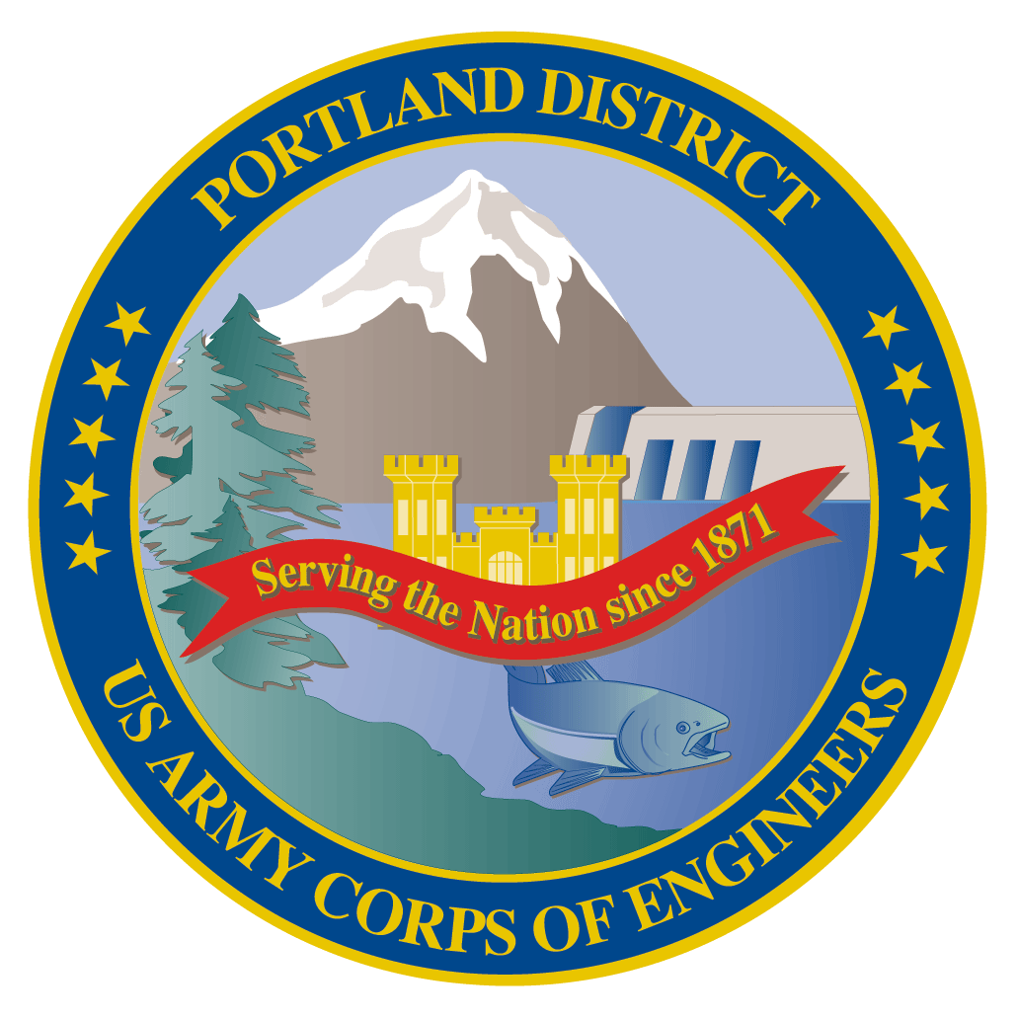Lower Columbia River Fish Facility Design Review Work Group (FFDRWG)

USACE, Portland District

May 2023 Agenda

Meeting Date: May 4, 2022, 09:00-12:00

Join Meeting: <https://usace1.webex.com/join/jacob.macdonald>

Join by phone (audio only, no Webex): (844) 800-2712 | Access Code: 1995 00 9820

## FFDRWG Meeting Files:

<https://pweb.crohms.org/tmt/documents/FPOM/2010/FFDRWG/FFDRWG.html>

## Introductions

FFDRWG members:

**BPA**

Scott Bettin

Kim Johnson

Christine Petersen

Greg Smith

Leah Sullivan

Ben Hausmann

**NOAA**

Blane Bellerud

Gabriel Brooks

Trevor Conder

Claire McGrath

Kelsey Swieca

Chris Magel

Kinsey Frick

**USFWS**

Dave Swank

Shelby Fowler

**States**

Erick Van Dyke (ODFW)

Charles Morrill (WDFW)

Jonathan Ebel (IDFG)

**CRITFC/Tribes**

Tom Lorz (CRITFC)

Blaine Parker (CRITFC)

Tom Skiles (CRITFC)

Laurie Porter (CRITFC)

Greg Silver (CRITFC)

Casey Baldwin (CTCR)

Michael Karnosh (CTGR)

Lawrence Schwabe (CTGR)

Torey Wakeland (CTGR)

Aaron Jackson (CTUIR)

Ralph Lampman (YN)

**NPCC**

Leslie Bach

Kris Homel

**FPC**

Erin Cooper

**PSMFC**

Alan Brower

Darren Chase

Roger Clark

Mark Leonard

Scott Livingston

Nicole Tancreto

Don Warf

**CENWD**

Doug Baus

Tim Dykstra

Dan Feil

Cindy Studebaker

Lisa Wright

Sean Tackley

Ian Chane

**CENWW**

Chris Peery

Steve Juhnke

Steve Sipe

**CENWP-OD**

Andrew Derugin

Jeanette Wendler

Tucker Gossett

Bob Cordie

Jeffrey Randall

Eric Grosvenor

Michael Lotspeich

Laura Rickets

Tammy Mackey

Robert Wertheimer

Patricia Madson

Darren Gallion

Kyle Tidwell

**CENWP-PM**

Jim Adams

Jeff Hicks

Erin Kovalchuk

Brad Eppard

Nathan McClain

Jake Macdonald

Jon Rerecich

Ida Royer

David Trachtenbarg

Scott Fielding

Rebecca Cates

**CENWP-ENC**

Adam Jones

Adam White

Brandt Bannister

Shari Dunlop

Chris Motti

Steve Schlenker

Max Wilson-Fey

Collin Porter

Dan Penn

Aaron Litzenberg

Mehdi Roshani

## Action items from previous meetings

1. Review notes from 2023-03-02 meeting

## Topics for FFDRWG Discussion/Review/Coordination

1. BON1 adult lamprey passage improvements – Erin Kovalchuk (PM), Adam White (TL), Andrew Derugin (FC)
   1. 90% DDR available for FFDRWG review at: [NWP FFDRWG and SRWG documents](https://pweb.crohms.org/tmt/documents/FPOM/2010/FFDRWG/FFDRWG.html) (https://pweb.crohms.org/tmt/documents/FPOM/2010/FFDRWG/FFDRWG.html)
   2. Contract is advertised on SAM.GOV for construction Winter 2023-2024
   3. Bradford Island LPS and wetted wall counting improvements – Madson
2. BON2 control section redesign – Erin Kovalchuk (PM), Shari Dunlop (TL), Andrew Derugin (FC)
   1. 60% DDR is available for FFDRWG reference (not for comment) at: [NWP FFDRWG and SRWG documents](https://pweb.crohms.org/tmt/documents/FPOM/2010/FFDRWG/FFDRWG.html) (https://pweb.crohms.org/tmt/documents/FPOM/2010/FFDRWG/FFDRWG.html)
   2. 90% DDR will be available for FFDRWG review & backcheck on or before 1-June
   3. PDT will provide an overview of changes from 60% to 90% at our 1-June FFDGWG meeting
3. TDA adult lamprey passage improvements – Erin Kovalchuk (PM), Adam White (TL), Jake Macdonald (FC)
   1. 90% DDR available for FFDRWG review at: [NWP FFDRWG and SRWG documents](https://pweb.crohms.org/tmt/documents/FPOM/2010/FFDRWG/FFDRWG.html) (https://pweb.crohms.org/tmt/documents/FPOM/2010/FFDRWG/FFDRWG.html)
   2. Contract is advertised on SAM.GOV for construction Winter 2023-2024 - White
4. JDA adult lamprey passage improvements – Erin Kovalchuk (PM), Adam White (TL), Jake Macdonald (FC)
   1. 100% DDR available for FFDRWG review at: [NWP FFDRWG and SRWG documents](https://pweb.crohms.org/tmt/documents/FPOM/2010/FFDRWG/FFDRWG.html) (https://pweb.crohms.org/tmt/documents/FPOM/2010/FFDRWG/FFDRWG.html)
   2. In-house construction, no 90% DDR and no BCOES. Construction in Winter 2022-2023.
   3. Construction progress update (Lotspeich)
5. BON2 FGE – Oseji Azuka (PM), Max Wilson-Fey (TL), Jon Rerecich (FC)
   1. Construction progress update - Rerecich
   2. Biological test AFEP research summary - Rerecich
6. TDA Backup AWS debris management – Erin Kovalchuk (PM), Mehdi Roshani (TL), Jon Rerecich (FC)
   1. Progress update – Rerecich
   2. 60% EDR alternative evaluation available for FFDRWG reference at: [NWP FFDRWG and SRWG documents](https://pweb.crohms.org/tmt/documents/FPOM/2010/FFDRWG/FFDRWG.html) (https://pweb.crohms.org/tmt/documents/FPOM/2010/FFDRWG/FFDRWG.html)
7. BON PIT Detection – Erin Kovalchuk (PM), Rebecca Cates (FC)
   1. Progress update on review of the plans from PSMFC – Cates
   2. 2019 PIT detection feasibility EDR available for FFDRWG reference at: [BON PIT Feasibility](https://pweb.crohms.org/tmt/documents/FPOM/2010/FFDRWG/BON%20PIT%20Feasibility/) (https://pweb.crohms.org/tmt/documents/FPOM/2010/FFDRWG/BON%20PIT%20Feasibility/)

## Other topics

1. John Day Ladder Cooling (*potential future project*) – Fielding/Grosvenor
   1. October 2022 South Fish Ladder Temperatures MFR available for FFDRWG reference at: [NWP FFDRWG and SRWG documents](https://pweb.crohms.org/tmt/documents/FPOM/2010/FFDRWG/FFDRWG.html) (<https://pweb.crohms.org/tmt/documents/FPOM/2010/FFDRWG/FFDRWG.html>)
   2. EDR alternative evaluation kickoff in FY 2024, pending budget approval
2. BON Spillway rock prevention – Erin Kovalchuk (PM), Adam Jones (TL), Rebecca Cates (FC)
   1. ‘Phase 1’ progress update – Cates
   2. 2022 ‘Phase 1a’ final report available for FFDRWG reference at: [NWP FFDRWG and SRWG documents](https://pweb.crohms.org/tmt/documents/FPOM/2010/FFDRWG/FFDRWG.html) (https://pweb.crohms.org/tmt/documents/FPOM/2010/FFDRWG/FFDRWG.html)
3. Discuss pros and cons of combining NWW and NWP FFDRWG meetings – Macdonald

## Upcoming meetings and field trips

1. Next regularly scheduled FFDRWG meeting – Thursday, June 1st @ 09:00
   1. Featuring an overview of changes from 60% to 90% DDR presented by the BON2 control section redesign PDT.
   2. In person meeting, discuss location
2. Field trip for FFDRWG and Corps-Tribal Lamprey Work Group to see JDA adult lamprey passage improvements in operation
   1. Partial day, In-person site visit in June
   2. Jake will schedule
3. Field trip for FFDRWG and Corps-Tribal Lamprey Work Group to see BON adult lamprey counting improvements in operation
   1. Partial day, In-person site visit in May-June
   2. Jake will schedule